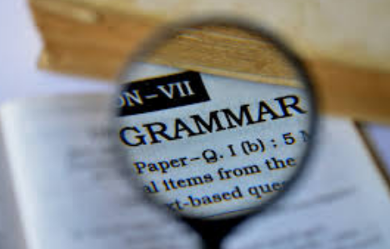
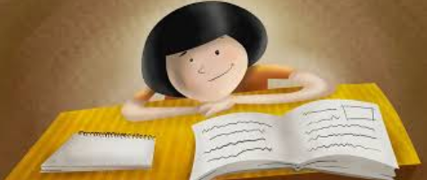

Year 6
SATs Revision Booklet
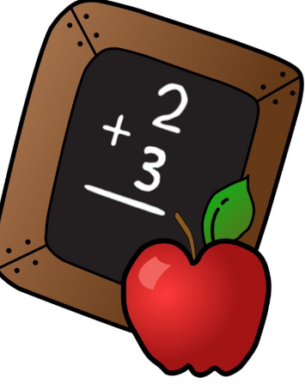


Reading

- Free@Last – Information Text

- Perhaps, by Vera Brittain – WW1 Poem

- Anne of Green Gables Extract


free@last is committed to providing opportunities, activities, mentoring and support for children and young people in Nechells, and to further their interests by working with their families, other agencies and relevant professionals.

The Story:
We began with a vision, a dream that saw the people of an impoverished and neglected inner-city community being set free from all that stopped them realizing and reaching their full potential in life. The vision became a reality in 1998 with the development of a support group for dads and an attempt at a community musical performance called Hopes & Dreams. free@last was established to develop and structure our work and was finally registered as a charity in December 1999 and a limited company in 2003.
free@last’s Vision is to improve the lives of the children and young people of Nechells and to turn a community of poverty into a community of prosperity and opportunity.
We are committed to providing opportunities, activities, mentoring and support for children and young people in Nechells, and to further their interests by working with their families, other agencies and the community as a whole.
The Future:
Our journey over the past few years has seen the need for our own youth facility evolve into a brand new youth and community centre. But this new place is not just a building, it is a beacon of hope and aspiration for the people of Nechells. Our aim is to provide a facility that is open to all who live and work in Nechells, regardless of age, race, religion, culture, lifestyle etc., but we don’t just want a building to run projects from, we want to be a centre for change. Whether encouraging young people to explore entrepreneurialism, developing cross generational clubs and performance groups or exploring a world outside Nechells, our Big Build is now focused on building peoples’ lives and enabling each and every person, who invites us to become involved with their lives, to live life to the full.
The Community:
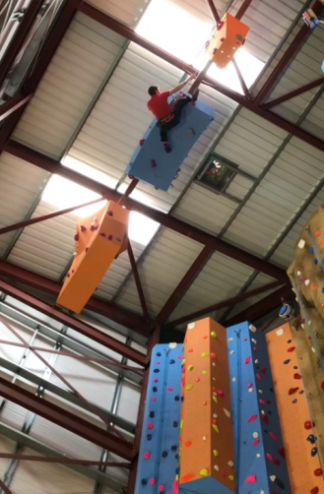
At free@last we believe that ‘it takes a whole village to raise a child’ and by this we mean that everyone in Nechells (or who has a responsibility or influence in our neighbour) has a part to play in eradicating poverty. Just working with a child or young person in isolation can only offer a limited amount of opportunity and support. However, working with their whole family, neighbours, local businesses, statutory agencies and other voluntary organisations, enables a more strategic and effective response to challenge and changing the things that need to be changed for improvement.
free@last offer a variety of community based services, including debt & benefit advice, volunteering, fun days, general support and advice and much more. We have also created the tri-sector group WeCANB7 and lead on the strategy to eradicate child poverty and create a community of prosperity and opportunity.

Contact: 49 Nechells Park Road, Nechells, Birmingham, B7 5PR UK
TEL: 0121 327 5959 FAX: 0121 327 8959

Questions related to ‘free@last’:
- Where is the ‘free@last’ situated? ___________________________________________ (1mk)

- When did their vision materialize? ______________________________________ (1 mk)

- What is the ‘vision’ of free@last? _____________________________________________________
____________________________________________________________________________ (2 mks)
- What does the phrase ‘beacon of hope’ suggest about their facility? _________________________
__________________________________________________________________________ (2mks)
- Find and copy a word which means ‘to motivate or inspire’: ___________________________ (1mk)

- What does it mean by ‘it takes a whole village to raise a child’? ______________________________
______________________________________________________________________________ (2mks)
- Give two benefits that this facility provides for young people:
- _____________________________________________________________

- _____________________________________________________________ (1 mk)

- Do you think this facility is best for children, adults of both? Give your reasons using evidence from the text:
Children Adults Both (3mks)
___________________________________________________________________________________
____________________________________________________________________________________
____________________________________________________________________________________
____________________________________________________________________________________
____________________________________________________________________________________
___________________________________________________________________________________

- Why do you think ‘Nechells’ was chosen as the location to build this facility? (3mks)

______________________________________________________________________________

_____________________________________________________________________________

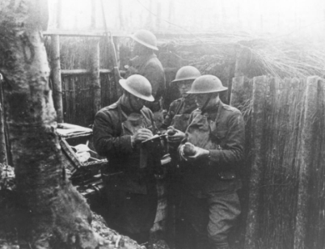

Perhaps, by Vera Brittain
(Dedicated to her fiance Roland Aubrey Leighton, who was killed at the age of 20 by a sniper in 1915, four months after she had accepted his marriage proposal)
Perhaps some day the sun will shine again,
And I shall see that still the skies are blue,
And feel once more I do not live in vain,
Although bereft of You.
Perhaps the golden meadows at my feet
Will make the sunny hours of spring seem gay,
And I shall find the white May-blossoms sweet,
Though You have passed away.
Perhaps the summer woods will shimmer bright,
And crimson roses once again be fair,
And autumn harvest fields a rich delight,
Although You are not there.
Perhaps some day I shall not shrink in pain
To see the passing of the dying year,
And listen to Christmas songs again,
Although You cannot hear.
But though kind Time may many joys renew,
There is one greatest joy I shall not know
Again, because my heart for loss of You
Was broken, long ago.
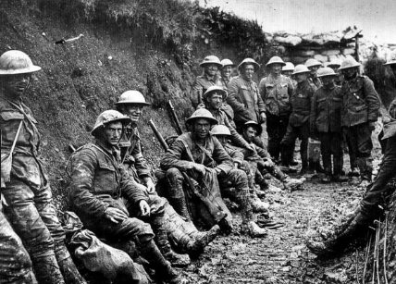
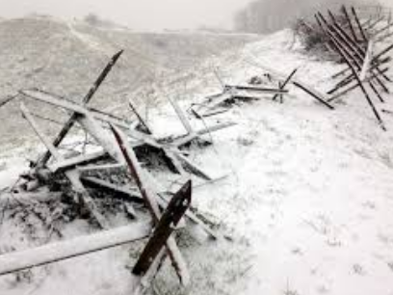

Questions related to ‘Perhaps’:
- Give an example of rhyme used? _____________ and _________________________ (1mk)

- What does ‘I do not live in vain’ mean? ________________________________________ (1 mk)

- Why does the poet start each verse with the same word? (2 mks)
__________________________________________________________________________________
_________________________________________________________________________________
- How are the last lines of each verse linked? Give an example: _________________________
__________________________________________________________________________ (2mks)
- Find and copy a word which means ‘light in colour/complexion’: _________________________ (1mk)

- Give an example of two seasons mentioned in the power, with evidence: (2mks)

- ________________________________________________________________________

- ________________________________________________________________________

- What is the ‘mood’ of this poem? Give reasons using evidence from the text: (3 mks)
__________________________________________________________________________________
____________________________________________________________________________________
____________________________________________________________________________________
____________________________________________________________________________________
________________________________________________________________________________________________
- What is the difference between the final verse and all the others? (2mks)
_________________________________________________________________________________
__________________________________________________________________________________
__________________________________________________________________________________
__________________________________________________________________________________
- How do you think Vera Brittain will cope in the future? Use evidence from the text. (3mks)
____________________________________________________________________________________
____________________________________________________________________________________
____________________________________________________________________________________
____________________________________________________________________________________

Anne of Green Gables
This extract is from Chapter 4: Morning at Green Gables
It was broad daylight when Anne awoke and sat up in bed, staring confusedly at the window through which a flood of cheery sunshine was pouring and outside of which something white and feathery waved across glimpses of blue sky.
For a moment she could not remember where she was. First came a delightful thrill, as something very pleasant; then a horrible remembrance. This was Green Gables and they didn’t want her because she wasn’t a boy!
But it was morning and, yes, it was a cherry-tree in full bloom outside of her window. With a bound she was out of bed and across the floor. She pushed up the sash—it went up stiffly and creakily, as if it hadn’t been opened for a long time, which was the case; and it stuck so tight that nothing was needed to hold it up.
Anne dropped on her knees and gazed out into the June morning, her eyes glistening with delight. Oh, wasn’t it beautiful? Wasn’t it a lovely place? Suppose she wasn’t really going to stay here! She would imagine she was. There was scope for imagination here.
A huge cherry-tree grew outside, so close that its boughs tapped against the house, and it was so thick-set with blossoms that hardly a leaf was to be seen. On both sides of the house was a big orchard, one of apple-trees and one of cherry-trees, also showered over with blossoms; and their grass was all sprinkled with dandelions. In the garden below were lilac-trees purple with flowers, and their dizzily sweet fragrance drifted up to the window on the morning wind.
Below the garden a green field lush with clover sloped down to the hollow where the brook ran and where scores of white birches grew, upspringing airily out of an undergrowth suggestive of delightful possibilities in ferns and mosses and woodsy things generally. Beyond it was a hill, green and feathery with spruce and fir; there was a gap in it where the gray gable end of the little house she had seen from the other side of the Lake of Shining Waters was visible.
Off to the left were the big barns and beyond them, away down over green, low-sloping fields, was a sparkling blue glimpse of sea.
Anne’s beauty-loving eyes lingered on it all, taking everything greedily in. She had looked on so many unlovely places in her life, poor child; but this was as lovely as anything she had ever dreamed.
She knelt there, lost to everything but the loveliness around her, until she was startled by a hand on her shoulder. Marilla had come in unheard by the small dreamer.
“It’s time you were dressed,” she said curtly.
Marilla really did not know how to talk to the child, and her uncomfortable ignorance made her crisp and curt when she did not mean to be.
Anne stood up and drew a long breath.
“Oh, isn’t it wonderful?” she said, waving her hand comprehensively at the good world outside.
“It’s a big tree,” said Marilla, “and it blooms great, but the fruit don’t amount to much never—small and wormy.”
“Oh, I don’t mean just the tree; of course it’s lovely—yes, it’s RADIANTLY lovely—it blooms as if it meant it—but I meant everything, the garden and the orchard and the brook and the woods, the whole big dear world. Don’t you feel as if you just loved the world on a morning like this? And I can hear the brook laughing all the way up here. Have you ever noticed what cheerful things brooks are? They’re always laughing. Even in winter-time I’ve heard them under the ice. I’m so glad there’s a brook near Green Gables. Perhaps you think it doesn’t make any difference to me when you’re not going to keep me, but it does. I shall always like to remember that there is a brook at Green Gables even if I never see it again. If there wasn’t a brook I’d be HAUNTED by the uncomfortable feeling that there ought to be one. I’m not in the depths of despair this morning. I never can be in the morning. Isn’t it a splendid thing that there are mornings? But I feel very sad. I’ve just been imagining that it was really me you wanted after all and that I was to stay here for ever and ever. It was a great comfort while it lasted. But the worst of imagining things is that the time comes when you have to stop and that hurts.”
“You’d better get dressed and come down-stairs and never mind your imaginings,” said Marilla as soon as she could get a word in edgewise. “Breakfast is waiting. Wash your face and comb your hair. Leave the window up and turn your bedclothes back over the foot of the bed. Be as smart as you can.”
Anne could evidently be smart to some purpose for she was down-stairs in ten minutes’ time, with her clothes neatly on, her hair brushed and braided, her face washed, and a comfortable consciousness pervading her soul that she had fulfilled all Marilla’s requirements. As a matter of fact, however, she had forgotten to turn back the bedclothes.
“I’m pretty hungry this morning,” she announced as she slipped into the chair Marilla placed for her. “The world doesn’t seem such a howling wilderness as it did last night. I’m so glad it’s a sunshiny morning. But I like rainy mornings real well, too. All sorts of mornings are interesting, don’t you think? You don’t know what’s going to happen through the day, and there’s so much scope for imagination. But I’m glad it’s not rainy today because it’s easier to be cheerful and bear up under affliction on a sunshiny day. I feel that I have a good deal to bear up under. It’s all very well to read about sorrows and imagine yourself living through them heroically, but it’s not so nice when you really come to have them, is it?”
“For pity’s sake hold your tongue,” said Marilla. “You talk entirely too much for a little girl.”
Thereupon Anne held her tongue so obediently and thoroughly that her continued silence made Marilla rather nervous, as if in the presence of something not exactly natural. Matthew also held his tongue,—but this was natural,—so that the meal was a very silent one.
As it progressed Anne became more and more abstracted, eating mechanically, with her big eyes fixed unswervingly and unseeingly on the sky outside the window. This made Marilla more nervous than ever; she had an uncomfortable feeling that while this odd child’s body might be there at the table her spirit was far away in some remote airy cloudland, borne aloft on the wings of imagination. Who would want such a child about the place?
Yet Matthew wished to keep her, of all unaccountable things! Marilla felt that he wanted it just as much this morning as he had the night before, and that he would go on wanting it. That was Matthew’s way—take a whim into his head and cling to it with the most amazing silent persistency—a persistency ten times more potent and effectual in its very silence than if he had talked it out.
When the meal was ended Anne came out of her reverie and offered to wash the dishes.
“Can you wash dishes right?” asked Marilla distrustfully.
“Pretty well. I’m better at looking after children, though. I’ve had so much experience at that. It’s such a pity you haven’t any here for me to look after.”
“I don’t feel as if I wanted any more children to look after than I’ve got at present. YOU’RE problem enough in all conscience. What’s to be done with you I don’t know. Matthew is a most ridiculous man.”
“I think he’s lovely,” said Anne reproachfully. “He is so very sympathetic. He didn’t mind how much I talked—he seemed to like it. I felt that he was a kindred spirit as soon as ever I saw him.”

Questions related to ‘Anne of Green Gables’:
- Was she welcome at the house? Use evidence to support your reasons? (2mks)
__________________________________________________________________________________

- Look at the paragraph which begins ‘But it was morning…’ how do you know she is excited? (1mk)
_______________________________________________________________________________

- Find and copy a word which means ‘a main branch of a tree’? (1mk)
_________________________________________________________________________________
- Was Anne used to living in places as beautiful as this? Use evidence from the text. (2mks)
_____________________________________________________________________________
____________________________________________________________________________
- What impression do you get of Anne and Marilla’s relationship? Use evidence (3mks)
_________________________________________________________________________________
_________________________________________________________________________________
_________________________________________________________________________________
_________________________________________________________________________________
- What phrase does Marilla use to tell Anne to stop talking? (1mk)
_______________________________________________________________________________
- How does Matthew contrast to Marilla? Use evidence to support your answer (3 mks)
__________________________________________________________________________________
____________________________________________________________________________________
____________________________________________________________________________________
____________________________________________________________________________________
- Do you think Anne will enjoy living there? Support your answers with evidence. (3mks)
_________________________________________________________________________________
__________________________________________________________________________________
__________________________________________________________________________________
__________________________________________________________________________________
- What does Anne mean by ‘kindred spirit’? (1mk)
____________________________________________________________________________________
____________________________________________________________________________________
____________________________________________________________________________________
____________________________________________________________________________________

GPS Questions:
- Use either me or I to complete the sentences below.
- Yesterday ___ went to the park.
- Mrs Forth asked ____ to take the pencils to Y5.
- After school, Molly and ___ had to collect the bags.

- Insert a pair of commas in the correct place in the sentence below.
Dean was finishing his work that the teacher had given him when he was called for lunch.

- Which sentence must end with a question mark? Tick one.
I’m not sure when you’re running
I’ll have to ask when you are running
When are you running in the race
When you are running we shall cheer

- Circle the two words which are synonyms of each other.
When I found the purse I was ecstatic, as I knew the old lady who misplaced it, thought she’d never locate it again.

- Insert a comma in the correct place in the sentence below.
Even though it had rained all night the sun was shining in the morning.

- Circle the adverbs in the sentence below.
Michael knew he was running slowly when John lapped him too.

- Which sentence is grammatically correct? Tick one.
Yesterday I am going to the cinema.
Last month we play in the park every day.
Tomorrow I will meet you by the gates.
Next week I found the missing ball.

- Give an examples of the follow types of nouns:
Common
Proper
Collective
Abstract

- Complete the table using an expanded noun phrase.
Book | The battered, stained book on the shelf
Shoe

- Complete the following using was or were.
- David and Mike ______ playing cricket in the park.
- Sarah’s dad _____ late picking her up.
- The books on the shelf _______ nearly toppling off.

- Draw a line to match each prefix to a word to make four different words. Use each prefix once.
Prefix |  | Word
ir |  | leading
im |  | responsive
un |  | mature
mis |  | relevant

- Complete the sentence so that it is written in the past progressive.
Last year I __________________ netball with the captain for England.

- Write a question below starting with which. Remember to punctuate your sentence correctly.
_____________________________________________________
- Which sentence is written in Standard English?
Tom and Mohamed come to our house today.
My dad was late picking me up.
Today I done my homework.
The rabbits was so cute leaping around.

- Tick the sentence that uses a dash correctly.
I hate - playing football I never win.
I hate playing football - I never win.
I hate playing - football I never win.
I hate playing football I never - win.

- Which sentence uses the underlined word as a noun? Tick one.
My uncle is extremely funny.
Would you like to see my slide?
I hate cricket, but I love swimming.
I saw him leave, but I have hope he will return.

- What is the grammatical term for the underlined part of this sentence? Tick one.
Amina loved her dog, but it hated her hugs.
Subordinate clause
Expanded noun phrase
Main clause
Prepositional phrases

- Insert a colon in the correct place in the sentence below.
I have two favourite desserts cheesecake and chocolate cake.

- Which sentence is punctuated correctly? Tick one.
When I charged, towards the goal everyone cheered in delight.

When I charged towards the goal, everyone cheered in delight.

When, I charged towards the goal, everyone cheered in delight.

When I charged towards, the goal everyone cheered in delight.

- Which modal verb shows that it is least likely to happen? Tick one.
I will win the trophy.
I cannot meet you after the film.
Tom might help us with the cooking.
Diana could speak on your behalf.

- Circle all the determiners in the sentence below.
When all the leaves have fallen from his trees, we will know it is winter and I will get some seeds to sow in preparation for next spring.

- Rewrite the following so that it is in the passive voice.
My gymnastics won the first place medals in the competition.

- Complete the sentence below with a noun formed from the verb help.
Mrs Grannel always remarked that I was a fabulous _________.

- Tick to show whether the following contractions are omission or possession.
 | Omission | Possession
Tom’s cat is vicious.
I’ll always try my hardest in goals.
Sara’s always late for her biology lessons.

- Replace the underlined word with the correct pronoun.

- When Milly was late for her piano lesson, Milly was sent home.

- Milly sulked all the way home.

- Her mother told her she would just have to go to the piano lesson next week.

- Bilal wants to know whether the weather was good on holiday.
Write the question he could ask.
_______________________________________________

- Which sentence is most formal?
I can’t wait until Christmas.
I would rather you waited for the cooker to be ready.
We won’t be able to play much.
Tilly would do loads for you if you asked.

- Underline the object in the sentence below.
The baker was exceptionally proud of the cakes he made.

- Name the punctuation that could be used instead of brackets below.
In the future, rockets (produced by NASA) will be able to land on Venus.

- Tick one box in each row to show whether the underlined noun is singular or plural.
 | singular | plural
The girls’ books were left on the table.
Only the princess’s shoes would sparkle that bright.
The climbers’ joy was evidence when they reached the summit.

- Circle all the prepositions in the sentence below.
When you cross over the bridge, you need to walk along the path and behind the waterfall.

- Rewrite the sentence below as direct speech. Remember to punctuation your sentence correctly.
I asked her if she had finished her work.
__________________________________________________

Arithmetic Questions:
Please allow 15 minutes to complete this test (20 possible marks)

1. | 845 - 60 |  |  |  |  |  |  |  |  |  |  |  |  |  |  |  |  |  |  |  | 1mk

2. | 967 + 45 |  |  |  |  |  |  |  |  |  |  |  |  |  |  |  |  |  |  |  | 1mk

3. | 2 + 4  9 9 |  |  |  |  |  |  |  |  |  |  |  |  |  |  |  |  |  |  |  | 1mk

4. | = 1956 + 295 |  |  |  |  |  |  |  |  |  |  |  |  |  |  |  |  |  |  |  | 1mk

5. | 104 ÷ 8 |  |  |  |  |  |  |  |  |  |  |  |  |  |  |  |  |  |  |  | 1mk

6. | 2.7 + 0.63 |  |  |  |  |  |  |  |  |  |  |  |  |  |  |  |  |  |  |  | 1mk

7. | 3,560, 013 = 3,000,000 + 500,000 + + 13 |  |  |  |  |  |  |  |  |  |  |  |  |  |  |  |  |  |  |  | 1mk

8. | 3 x 1  2  5 3 |  |  |  |  |  |  |  |  |  |  |  |  |  |  |  |  |  |  |  | 1mk

9. | 3³ - 4² |  |  |  |  |  |  |  |  |  |  |  |  |  |  |  |  |  |  |  | 1mk

10 | 700 x 600 |  |  |  |  |  |  |  |  |  |  |  |  |  |  |  |  |  |  |  | 1mk

11 | 2.16 ÷ 6 |  |  |  |  |  |  |  |  |  |  |  |  |  |  |  |  |  |  |  | 1mk

12 | 143 x 89 |  |  |  |  |  |  |  |  |  |  |  |  |  |  |  |  |  |  |  | 2mk

13 | 66.69 ÷ 13 |  |  |  |  |  |  |  |  |  |  |  |  |  |  |  |  |  |  |  | 2mk

14 | 13 + 25 x 2 |  |  |  |  |  |  |  |  |  |  |  |  |  |  |  |  |  |  |  | 1mk

15 | 5 - 3  1  2  6 4 |  |  |  |  |  |  |  |  |  |  |  |  |  |  |  |  |  |  |  | 1mk

16 | 2 ÷ 8  7 |  |  |  |  |  |  |  |  |  |  |  |  |  |  |  |  |  |  |  | 1mk

17 | 0.0678 x 1000 |  |  |  |  |  |  |  |  |  |  |  |  |  |  |  |  |  |  |  | 1mk

18 | 31% of 1256 |  |  |  |  |  |  |  |  |  |  |  |  |  |  |  |  |  |  |  | 1mk

Tricky Reasoning Questions:

1. | A cube with a volume of 27³is unfolded to form a net. If it is placed on a piece of paper. What size piece of paper would you need?  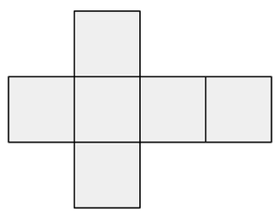  Width:  Length: | 2mk

2 |   Three friends share a giant pancake. Leah has 3/4 of it and Amina has 1/6. How much is left for Neil? | 1mk

3 | Write these measurements in order, starting with the shortest:  49cm 4.95m 0.495m 409cm 4.9m  shortest longest | 1mk

4 | The diagram is not drawn to scale. Find the size of the angle ‘a’  60°  a  a = | 1mk

5 | The temperature in Paris on Thursday was -3°c and it London it was 2°c. What was the average temperature?  degrees | 1mk

6 | The following sequence uses the rule ‘add 6’. Tom said “The number 660 will be in the sequence.” Is he correct? Explain your answer.  7 13 19 25 31 | 1mk

8 | David scored 90 out of 120 in a Maths test, and Mina scored 70%. Who performed best in the test? Explain your answer. | 1mk

9 | If 6a + 9 = 33  What is the value of a?  a =  Using the above, what is the value of ‘b’ if  b =  5b +3a = 2 | 2mk

10 | A sports club has 1,324 children as members. They decide to go on a trip to the seaside. If each coach held 26 children, how many coaches would they need?  coaches | 2mk

11 | Tim went away for 25% of the days in February. Andy went away for 3 days more than Tim. How many days did Andy go away for?  days | 2mk

12 | The radius of circle A is 6cm. Circle B is enlarged by a scale factor of 1:4. What is the radius of circle B?  Circle A Circle B | 1mk

13 | Huda finished her homework in 54 minutes 13 seconds. Andrew took 2 minutes 25 seconds less than Huda. How long did it take Andrew?  Fred took 6 minutes and 55 seconds longer than Huda. How long did Andrew  take? | 2mk

